PROJECT REPORT

ON

WEKA’S

MACHINE LEARNING CAPABILITIES

SUBMITTED BY:

K SHREYAS KUMAR

ABSTRACT

Weka (Waikato Environment for Knowledge Analysis) is a comprehensive open-source suite of machine learning algorithms and data preprocessing tools. This project utilizes Weka's capabilities to analyze/classify/predict within a dataset.

This project addresses Weka's machine learning capabilities. The results demonstrate the effectiveness of Weka in achieving what the project set out to achieve.

"Weka's machine learning tools provide valuable insights in diverse fields. This project applies Weka to superficial data. The analysis aims to prove Weka's efficiency

INTRODUCTION

Weka (Waikato Environment for Knowledge Analysis) is a powerful open-source suite of machine learning software tools developed at the University of Waikato, New Zealand. It offers a user-friendly graphical interface and a vast collection of algorithms, making it accessible for both experts and those new to the world of data analysis.

**What Makes Weka Stand Out**

* **Versatility:** Weka covers a wide range of data mining tasks, including:
  + **Preprocessing:** Cleaning, transforming, and preparing your data
  + **Classification:** Building models to predict categories (e.g., spam vs. non-spam emails)
  + **Regression:** Modeling relationships between variables to predict continuous values (e.g., stock prices)
  + **Clustering:** Identifying natural groupings within data
  + **Association Rule Mining:** Uncovering relationships between items or attributes (e.g., "Customers who bought X also bought Y")
  + **Visualization:** Exploring data patterns and relationships graphically
* **Accessibility:** Weka's graphical interface eliminates the need for extensive programming knowledge. Users can easily load data, experiment with different algorithms, and evaluate their results.
* **Extensibility:** Weka can be extended through plugins and its Java-based architecture allows for integration with other tools.

**Where Weka Shines**

* **Research and Education:** Weka is widely used in academic settings for teaching machine learning concepts and conducting research.
* **Rapid Prototyping:** Its ease of use makes it ideal for quickly testing different machine learning approaches on a problem.
* **Real-World Applications:** Weka can be utilized in areas like business intelligence, healthcare, scientific analysis, and many more.

**Problem Statements**

* **Classification**
  + **Problem:** A medical dataset has patient symptoms and test results. Can we accurately predict the diagnosis of disease X?
  + **Problem:** Customer emails need to be filtered into categories (complaint, inquiry, general feedback). Can we build a model to automate this?
  + **Problem:** Large amounts of network traffic data need to be analyzed. Can we identify patterns that suggest malicious intrusions?
* **Regression**
  + **Problem:** Historical housing sales data is available. Can we predict future home prices within a specific area based on various features?
  + **Problem:** A manufacturing company seeks to optimize production. Can we model the relationship between various process variables and output quality?
  + **Problem:** Is it possible to predict customer lifetime value based on initial purchase behavior and demographics?
* **Clustering**
  + **Problem:** A marketing team has customer data. Can we identify natural customer segments based on demographics and purchasing habits?
  + **Problem:** Can we identify similar genetic sequences within a large biological dataset to aid in research?
  + **Problem:** A news organization has a large corpus of articles. Can we group them into clusters based on topic?
* **Association Rule Mining**
  + **Problem:** A supermarket wants to understand purchasing patterns. Can we uncover frequent item-set combinations to inform product placement and promotions?
  + **Problem:** A website tracks user browsing behavior. Can we find associations between pages visited to personalize recommendations?
  + **Problem:** Can we identify any commonalities in the symptoms reported by patients to potentially uncover new disease relationships?

AND MANY MORE......

SYSTEM REQUIREMENT SPECIFICATION

A System Requirement Specification (SRS) is basically an organization’s

understanding of a customer or potential client’s system requirements and

dependencies at a particular point prior to any actual design or development

work. The information gathered during the analysis is translated into a

document that defines a set of requirements. It gives a brief description of

the services that the system should provide and also the constraints under

which the system should operate. Generally, SRS is a document that

completely describes what the proposed software should do without

describing how the software will do it.

SRS document itself states in precise and explicit language those functions

and capabilities a software system (i.e., a software application, an

ecommerce website and so on) must provide, as well as states any required

constraints by which the system must abide. SRS also functions as a

blueprint for completing a project with as little cost growth as possible. SRS

is often referred to as the “parent” document because all subsequent project

management documents, such as design specifications, statements of work,

software architecture specifications, testing and validation plans, and

documentation plans, are related to it.

Requirement is a condition or capability to which the system must conform.

Requirement Management is a systematic approach towards eliciting,

organizing and documenting the requirements of the system clearly along

with the applicable attributes.

4.1 FUNCTIONAL REQUIREMENT

Functional Requirement defines a function of a software system and how the

system must behave when presented with specific inputs or conditions.

These may include calculations, data manipulation and processing and other

specific functionality. In this system following are the functional

requirements: -

Following are the functional requirements on the system:

i. The entire control model set must be translated to C output Code.

ii. Inputs must be models designed using CLAW design components along

with standard design components,

iii. Multiple design models must be processed and the result must be combined

to obtain a single output file

4.2 NON-FUNCTIONAL REQUIREMENT

Nonfunctional requirements are the requirements which are not directly

concerned with the specific function delivered by the system. They specify

the criteria that can be used to judge the operation of a system rather than

specific behaviors. They may relate to emergent system properties such as

reliability, response time and store occupancy.

Nonfunctional requirements arise through the user needs, because of budget

constraints, organizational policies, the need for interoperability with other

software and hardware systems or because of external factors such as: -

1. Product Requirements

2.Organizational Requirements

3.User Requirements

4.Basic Operational Requirements

4.2.1 PRODUCT REQUIREMENTS

Platform Independency: Standalone executables for embedded systems

can be created so the algorithm developed using available products could be

downloaded on the actual hardware and executed without any dependency

to the development and modeling platform.

Correctness: It followed a well-defined set of procedures and rules to

compute and also rigorous testing is performed to confirm the correctness of

the data.

Ease of Use: Model Coder provides an interface which allows the user to

interact in an easy manner.

Modularity: The complete product is broken up into many modules and

well- defined interfaces are developed to explore the benefit of flexibility of

the product.

Robustness: This software is being developed in such a way that the overall

performance is optimized and the user can expect the results within a limited

time with utmost relevance and correctness Nonfunctional requirements are

also called the qualities of a system. These qualities can be divided into

execution quality & evolution quality. Execution qualities are security &

usability of the system which are observed during run time, whereas

evolution quality involves testability, maintainability, extensibility or

Scalability.

4.2.2 ORGANIZATIONAL REQUIREMENTS

Process Standards: The standards defined by DRDO are used to develop

the application which is the standard used by the developers inside the

defense organization.

Design Methods: Design is one of the important stages in the software

engineering process. This stage is the first step in moving from problem to

the solution domain. In other words, starting with what is needed design

takes us to work how to satisfy the needs.

4.2.3 USER REQUIREMENTS

o The coder must request the name of the model file to be processed

o In case of multiple files, the coder must ask the names of the files

sequentially.

o The output file must be a C code translated from the model.

o Only a single output file must be created even if multiple input files are

Provided.

4.2.4 BASIC OPERATIONAL REQUIREMENTS

The customers are those that perform the eight primary functions of systems

engineering, with special emphasis on the operator as the key customer.

Operational requirements will define the basic need and, at a minimum, will

be related to these following points: -

Mission profile or scenario: It describes the procedures used to accomplish

mission objectives. It also finds out the effectiveness or efficiency of the

system.

Performance and related parameters: It points out the critical system

parameters to accomplish the mission

Utilization environments: It gives a brief outline of system usage. Finds out

appropriate environments for effective system operation.

Operational life cycle: It defines the system lifetime.

4.2.5 SYSTEM CONFIGURATION

• H/W System Configuration:

o Processor - Pentium –IV Speed - 1.1 Ghz

o RAM - 4GB RAM

o Hard Disk - 20 GB

o Key Board - Standard Windows Keyboard

o Mouse - Two or Three Button Mouse

o Monitor - SVGA

• S/W System Configuration:

o Operating System: XP/7/8/8.1/10

o Coding Language: : Python – 3.7.0

Methodology

Weka’s GUI

1.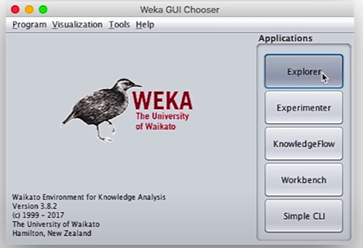

**Select the Weka Explorer:** This is the primary interface for most data analysis tasks in Weka. Click the "Explorer" button to proceed.

2.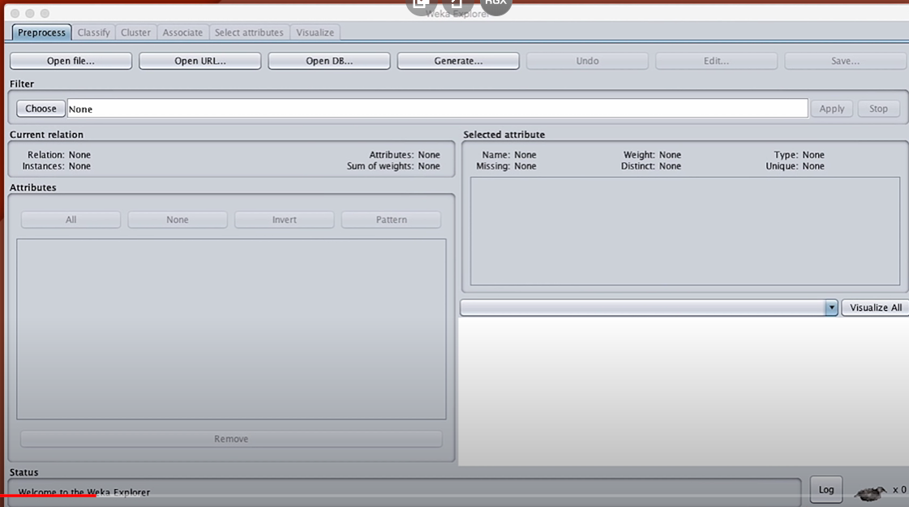**The Weka Explorer Interface: Overview**

* **Tabs:** You'll see several tabs at the top:
  + **Preprocess:** Data loading, cleaning, and transformation
  + **Classify:** Algorithm selection, model building, evaluation
  + **Cluster:** Clustering algorithms
  + **Associate:** Association rule mining
  + **Select attributes:** Feature selection techniques
  + **Visualize:** Graphical exploration of your data

3. **Loading Your Dataset**

1. **Preprocess Tab:** This is usually your starting point.
2. **Open file...** Under the "Open file..." button, locate your dataset file. Weka supports common formats like CSV, ARFF, etc. Click "Open".
3. **Inspect Your Data:**
   * The current dataset's name and characteristics will be displayed.
   * Click on individual attributes to see summary statistics and distributions.

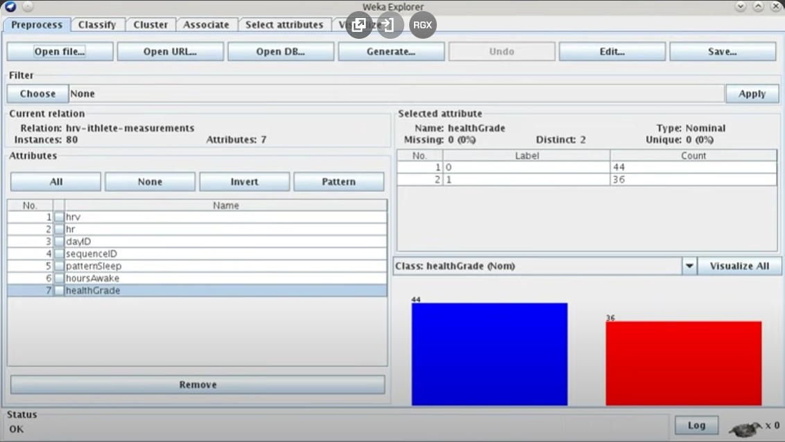

4. **Preprocessing Your Data**

**Identify Issues:**

* + Look for missing values (indicated by "?")
  + Look for unusual distributions or outliers.
  + Check if categorical attributes have the correct data type.

**Apply Filters:**

* + The "Choose" button opens Weka's filter menu. Categories include:
    - "Remove" for deleting attributes or instances
    - "Discretize" for numerical-to-categorical conversion
    - "Normalize" or "Standardize" to rescale numerics.
    - Many more for specific data transformations.

**Observe Changes:** After applying each filter, re-examine your data to ensure the changes

make sense.

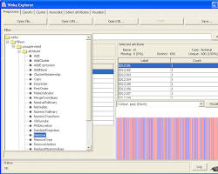

5. **Choosing a Classification Algorithm:**

* **Switch to the 'Classify' tab:** Here you'll find tons of machine learning algorithms.
* **Categories:** Explore categories like:
  + 'trees' (e.g., J48 decision trees)
  + 'bayes' (e.g., Naive Bayes classifier)
  + 'lazy' (e.g., k-Nearest Neighbors)
  + 'functions' (e.g., Support Vector Machines)
* **Select an algorithm:** Experimenting is key! Start with a simple algorithm that suits your problem type.

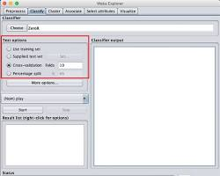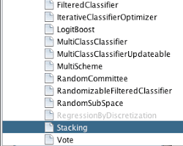

**6.Training and Testing:**

* **Cross-validation (recommended):** Use a chosen percentage split or cross-validation for more robust evaluation.
* **Setting Testing Options:**

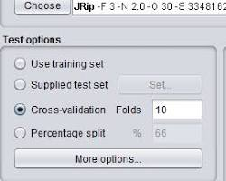

* **Example: Cross-validation Setup**

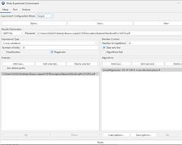

**6.Analyzing Results:**

* **'Classifier output' Panel:** Weka provides various metrics like accuracy, precision, recall, F-measure, confusion matrix, etc.
* **Right-click on the result:** Choose 'Visualize classifier errors' to see misclassified instances, or 'Visualize tree' if using a decision tree.
* **Classifier Output Panel:**

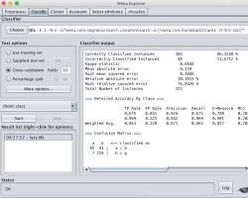

**Visualization Options:**

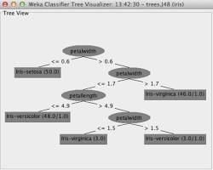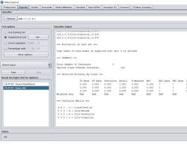

WEKA’S API

**Prerequisites**

**1.Java Development Kit (JDK):** You'll need a JDK installed on your system to compile and run Java code. Download it from the official Oracle website if you don't have one.

**2.Weka JAR File:**<https://weka.sourceforge.io/doc.dev/overview-summary.html.>

**Setting Up Your Project**

* **Create a Java project:** Use your favorite IDE (e.g., Eclipse, IntelliJ) or text editor and create a new Java project.
* **Include the Weka JAR:** Add the downloaded weka.jar file to your project's build path or classpath. The method will vary slightly depending on your IDE.

**1.Loading a Dataset**

import weka.core.converters.ConverterUtils.DataSource;  
import weka.core.Instances;  
  
public class GettingStarted {  
 public static void main(String[] args) throws Exception {  
 // Assuming your dataset is in CSV format  
 DataSource source = new DataSource("your_dataset.csv");   
 Instances data = source.getDataSet();  
  
 // Specify the index of the class attribute (if not the last one)  
 if (data.classIndex() == -1) {  
 data.setClassIndex(data.numAttributes() - 1);  
 }  
 }  
}

**2.Building a Classifier**

import weka.classifiers.bayes.NaiveBayes;  
  
// ... (loading dataset ,same as above)  
  
// Create a simple Naive Bayes classifier  
NaiveBayes classifier = new NaiveBayes();  
classifier.buildClassifier(data); // Train the model

**3.Evaluation (Using Cross-Validation)**

import weka.classifiers.Evaluation;  
  
// ... (loading and building classifier,same as above)  
  
// 10-fold cross-validation  
Evaluation evaluation = new Evaluation(data);  
evaluation.crossValidateModel(classifier, data, 10, new Random(1)); // Random seed   
  
System.out.println(evaluation.toSummaryString());

**4.Making Predictions**

// Load new data to make predictions on (e.g., newData.arff)  
DataSource newDataSource = new DataSource("newData.arff");   
Instances newData = newDataSource.getDataSet();   
// ... set class index if needed  
  
// Use the trained model for predictions  
for (int i = 0; i < newData.numInstances(); i++) {  
 double predicted = classifier.classifyInstance(newData.instance(i));  
 System.out.println("Predicted class: " + predicted);  
 }

FURTHER....

**Integration Methods**

* **Direct API Integration:**
  + Use Weka's Java API directly within your chatbot's codebase (if the chatbot is built in Java). This gives the most flexibility and customization.
* **REST API:**
  + Create a REST API wrapper around your Weka models. Your chatbot, regardless of programming language, can then send requests to this API for predictions and analysis.
* **Intermediate Data Storage:**
  + Have your chatbot log conversations in a database or file format. Weka can then periodically process this data for offline analysis and model updates.

**Limitations and Considerations**

* **Real-time Speed:** Weka might not be the fastest tool for real-time processing within the chatbot itself, especially with large datasets. You might need to optimize models or use a hybrid approach.
* **NLP Focus:** Weka's strength lies in the machine learning aspect. You'll likely need additional tools or libraries for the core natural language processing (NLP) components of a chatbot (tokenization, stemming, etc.).
* **Developer Expertise:** Seamless integration often requires a good understanding of both machine learning concepts and chatbot development.

**Benefits**

* **Improved Accuracy:** Well-trained Weka models can lead to more accurate intent classification and sentiment analysis, leading to better chatbot responses.
* **Customization:** Using Weka gives you greater control over the models compared to off-the-shelf chatbot platforms.
* **Data-Driven Adaptability:** Weka enables the chatbot to learn from interactions, leading to improved user experiences over time.

CONCLUSION

Weka's open-source nature, user-friendly interface, and extensive functionalities make it a powerful and accessible tool for data mining and machine learning tasks. Its continued development and growing user community ensure its ongoing relevance in various sectors.

## WEKA Limitation

**1. Memory and Dataset Size:**

* **Java Heap Space:** Weka, being Java-based, can run into "out of memory" errors when handling very large datasets. Your machine's RAM plays a significant role here.
* **Workarounds:**
  + Increase Weka's memory allocation
  + Use sampling techniques to reduce dataset size
  + Explore incremental learning algorithms (these load data in chunks)

**2. Algorithm Focus and Speed:**

* **Emphasis on traditional methods:** Weka excels in classic machine learning algorithms like decision trees, support vector machines, etc. It can be less up-to-date on the very latest deep learning architectures.
* **Not optimized for big-data speed:** Weka isn't the best choice for massive datasets or situations prioritizing real-time, high-speed prediction.

**3. User Interface and Flexibility:**

* **Steeper Learning Curve:** While functional, Weka's GUI can be less intuitive compared to some modern machine learning tools with drag-and-drop interfaces.
* **Limited Customization:** Weka offers less granular control over algorithm implementations compared to coding in frameworks like TensorFlow or PyTorch.

**4. Other Considerations:**

* **Multi-Relational Data:** Weka primarily assumes data is in a single flat file format (ARFF). It's not built for directly handling complex relational data.
* **Text Mining Expertise:** While Weka can handle text data, it requires preprocessing and might not be as strong in this area compared to dedicated text mining tools.

REFERENCES/BIBLIOGRAPHY

* Witten, Ian H., et al. Data Mining: Practical Machine Learning Tools and Techniques. 4th ed., Morgan Kaufmann, 2016.
* Weka 3: Data Mining Software in Java. University of Waikato,
* Witten, I. H., Frank, E., Hall, M. A., & Pal, C. J. (2016). Data mining: Practical machine learning tools and techniques (4th ed.). Morgan Kaufmann.
* Weka 3: Data Mining Software in Java. (n.d.). University of Waikato. Retrieved from
* Witten, Ian H., Eibe Frank, Mark A. Hall, and Christopher J. Pal. 2016. Data Mining: Practical Machine Learning Tools and Techniques. 4th ed. Burlington, MA: Morgan Kaufmann.
* University of Waikato. “Weka 3: Data Mining Software in Java.” Accessed Month,